MARKING KEY

input.doc

SECTION ONE—MULTIPLE CHOICE [40 marks]

Questions 1–20

1 B | 11 B
2 C | 12 A
3 D | 13 C
4 B | 14 D
5 D | 15 D
6 A | 16 A
7 D | 17 B
8 A | 18 A
9 C | 19 D
10 D | 20 C

SECTION TWO—SHORT ANSWERS [120 marks]
Questions 1–6

Question 1 [20 marks]

(a) Graph all these data on the single grid provided.

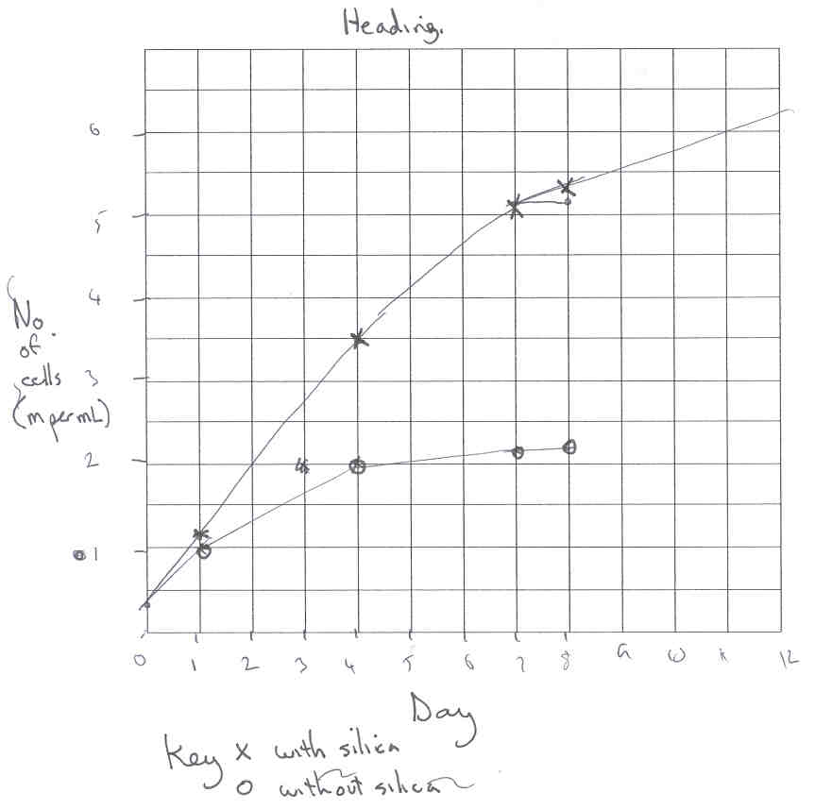

Description | Marks
Correct choice of graph—line graph | 1
Appropriate labels, scale and units on axes | 1
Key given | 1
Accuracy of plotting points | 1
Heading: concise, explanatory title identifying each set of data. | 1

(b) For this investigation give the following:

- A hypothesis this investigation may be testing.

Description | Marks
States hypothesis—Silica will increase the growth rate of Chaetoceros sp. or similar. | 2

(ii) The dependent variable

Description | Marks
States the dependent variable—growth rate millions per mL. | 1

(iii) The independent variable

Description | Marks
States the independent variable—presence or absence of silica. | 1

(c) Name four variables that would have to be controlled for the investigation to be reliable.

Description | Marks
States any four controlled variables such as:  - same environmental conditions e.g. O₂, CO₂, pH, temperature  - light intensity  - container the same shape or size  - same source of alga  - time of day of sampling  - method of cell counting. | 4
States 1 to 3 controlled variables. | 1-3

(d) Write a conclusion from these data on growth of Chaetoceros.

Description | Marks
States a relationship between the growth in silica and no silica such as:  - absence of silica from the culture medium for Chaetoceros results in depressed growth or  - chaetoceros grows better with silica in the culture medium than without silica.  or similar | 2

Question 2 [20 marks]

Diagrams showing a human sperm cell and a human ovum.

(a) (i) Write the name of the structure that would contain the cells’ DNA.

Description | Marks
The nucleus. | 1

(ii) Name the type of cell division which gives rise to sperm cells.

Description | Marks
Meiosis (reduction division). | 1

(iii) Sperm cells are haploid. What does this mean?

Description | Marks
Contain half the normal chromosome number of a body (somatic) cell. | 1

(b) (i) Sperm cells have many mitochondria. What does this suggest about the special needs of sperm cells?

Description | Marks
Energy need/requirement. | 1

(ii) Name two inputs and two outputs of sperm cell mitochondria.

Description | Marks
Inputs: oxygen, glucose, ADP, P: any two. | 2
Outputs: carbon dioxide, water, energy (ATP), metabolic waste: any two. | 2

(iii) The seminal fluid which transports the sperm cells contains large amounts of a simple sugar called fructose. What is the likely function of this simple sugar?

Description | Marks
Energy source for respiration. | 1

A student examined four cell types from four different living organisms using an electron microscope. She placed a mark in the table below when she was certain a cell component (organelle) was present, otherwise she left the space blank.

(c) From these observations the student made the following conclusions. Indicate whether, on the basis of the data in the table, you believe her conclusions are true or false. Give reasons for your decision in each case.

(i) Cells II and III must be from animals.

Description | Marks
False. | 1
Cell II has chloroplast and cell wall which are plant features. | 1

(ii) Cells I and IV require no energy.
Description | Marks
False. | 1
All living cells require energy. | 1

(d) Two of the cell components (organelles) in the table shown earlier are able to produce ATP in respiration.

- Name the two cell components (organelles) and indicate whether they use aerobic or anaerobic respiration.

Description | Marks
Mitochondria: aerobic respiration. | 2
Cytoplasm: anaerobic respiration. | 2

(ii) Write the word equation for the reaction occurring in aerobic respiration.

Description | Marks
Glucose + oxygen ---------- carbon dioxide + water + energy. | 1

(e) From the structure of the cells shown in the diagrams at the beginning of this question and the information you have been given, give two reasons why sperm cells have a higher surface area to volume ratio than ova.

Description | Marks
Long thin shape of sperm cell: less volume than spherical ova. | 1
Sperm are motile so need more fructose from surroundings OR  Higher SA:Vol increases rate of diffusion of fructose into sperm cell. | 1

Question 3 [24 marks]

(a) Using symbols of your own choosing and evidence from the pedigree, explain clearly the mechanism of inheritance of the heart disease.

Description | Marks
Autosomal dominant. | 1
Symbols e.g. A = disease/affected, a = healthy/normal. | 1
Evidence: II7 x II8 (both affected) produce III5 (unaffected offspring). | 1
Reference to cross disproving sex-linkage e.g. I1 or II8 produce unaffected offspring. | 1

(b) Indicate the likely genotype(s) of the following four individuals.

Description | Marks
I 2: aa (homozygous recessive). | 1
II 7: Aa (heterozygous). | 1
III 4: aa (homozygous recessive). | 1
III 8: Aa or AA. (heterozygous or homozygous dominant). | 1

(c) The farmer plans to cross II 4 and III 2.

(i) What is the probability that their first offspring will have the disease?
Show your working.

Description | Marks
Probability 50% | 1
Parents: Aa x aa  Gametes: ½A + ½a ½a + ½a | 1
F1 generation:  A a  a  a | 1
  Aa | Aa
  Aa | Aa
F1 genotype: ½Aa + ½aa  [F1 phenotype: ½ disease + ½aa normal] | 1

(ii) What is the probability that their second offspring will be a normal male?
Show your working.

Description | Marks
25% | 1
50% chance of being male | 1
50% chance of normal trait | 1
½ x 50% = 25% | 1

(d) Define the following terms [4 marks]

(i) Alleles.

Description | Marks
The different forms or variants of a certain gene | 1

(ii) Homozygous.

Description | Marks
A pair of alleles of a certain gene are the same for the genotype of a particular organism | 1

(iii) Heterozygous

Description | Marks
A pair of alleles of a certain gene are different in the genotype of a particular organism | 1

(iv) Autosomal chromosomes (autosomes)

Description | Marks
Pairs of chromosomes which are not the sex chromosomes | 1

(e) The farmer wishes to know whether individual III 6 is homozygous or heterozygous. How could this be determined? Show your working.

Description | Marks
Test cross with double recessive: III6 x aa. | 1
If III6 is AA expect all offspring to be heterozygous (Aa). | 1
If III6 is Aa expect ratio as in (c): ½Aa + ½aa. | 1
Several lambs (progeny) would be needed. | 1

Question 4 [16 marks]
(This question is common to the stage three sample examination Q16.)

(a) (i) Name two possible sources of excess nutrients in the Peel Inlet.

Description | Marks
Fertilisers from agricultural and domestic sources. | 1
Sewage from domestic leach tanks. | 1

(ii) Name two possible causes of water turbidity in the Peel Inlet.

Description | Marks
Boating activity. | 1
Strong winds. | 1

(b) (i) Briefly explain two ways the turbidity could affect the population of macro algae.

Description | Marks
Reduced light reaching plants reduces photosynthesis. | 1
Oxygen levels reduced. | 1

(ii) Explain briefly how the turbidity would affect the populations of commercially important species such as larger fish, crabs and prawns.

Description | Marks
Producers are food for the consumers and therefore support the food web. | 1
Number of producers reduced will also reduce consumer populations. | 1

(c) (i) Draw a biomass pyramid for the following food chain.
Phytoplankton → prawns → waterbirds

Description | Marks
Drawing | 1
  birds
  prawns
  phytoplankton
Labelling | 1

(ii) Briefly explain the shape of the food pyramid you have drawn in terms of energy flow and dissipation.

Description | Marks
Energy flow reduced when transferred to next level (next organism in the food chain). | 1
Energy is ‘lost’ as heat which dissipates at each level. | 1

(iii) Give two reasons why spraying insecticide is bad for the ecosystem. Briefly explain your answers.

Description | Marks
Non-specific: affects all insects including those that are beneficial. | 1
Affects the food web: insects. | 1

(iv) Suggest two methods, besides spraying, which could help reduce the mosquito population.

Description | Marks
Release sterile mosquitoes into the population. | 1
Increase natural predators/introduce disease or predator. | 1

Question 5 [20 marks]

Cells use a range of structures and processes to regulate their metabolism and to interact with the environment.

(a) Give two reasons why organisms need each of the following.

- DNA

Description | Marks
Protein synthesis. | 1
Store/transfer genetic material. | 1

- Nutrients

Description | Marks
Provide materials for growth. | 1
Provide energy for living/metabolic processes. | 1

- Briefly describe, or present a clearly labelled diagram, to illustrate the process of osmosis.

Description | Marks
Net movement of water across a semi-permeable membrane. | 1
Movement (of water) from a solution of lower concentration to one of higher. | 1
Larger molecules unable to pass through semi-permeable membrane. | 1

(c) (i) Define photosynthesis.

Description | Marks
Process by which organic compounds/sugars/carbohydrates are produced. | 1
Produced from inorganic compounds using solar/light energy. | 1

(ii) What are the raw materials required for photosynthesis?

Description | Marks
Water. | 1
Carbon dioxide. | 1

(iii) What are the products of photosynthesis?

Description | Marks
Sugars/carbohydrates/glucose/starch. | 1
Oxygen. | 1

(vi) Name the cellular structures (organelles) essential for photosynthesis and explain their role in the process of photosynthesis?

Description | Marks
Chloroplasts. | 1
Capture/trap light energy. | 1
Using chlorophyll. | 1

- Specialised structures are present in typical leaf tissue to aid the process of photosynthesis. Name these structures and briefly explain their role.

Description | Marks
Stomata/guard cells. | 1
Controlled opening that allows carbon dioxide to enter the plant from the air. | 1

(d) (i) Suggest one way in which the processes of diffusion and osmosis are similar.

Description | Marks
No energy is required as substances move along a concentration gradient. | 1

(ii) Suggest one way in which the processes of diffusion and osmosis are different.

Description | Marks
Osmosis is the net movement of WATER against a concentration gradient. | 1

Question 6 [20 marks]

(a) Biological classification is based upon a hierarchical system of grouping organisms.

- Briefly describe three key features of this particular system.

Description | Marks
Based on grouping organisms with similar structural features. | 1
Gross to specific: kingdom/phylum to species. | 1
Each species has two names (binominal nomenclature) in latin or greek. | 1

(ii) In classifying plants, classification is mainly based upon the presence of cellular features such as:

Description | Marks
Presence of a cellulose cell wall. | 1
Presence of chloroplasts. | 1
Large vacuole. | 1

(iii) List three reasons why it is important to classify organisms?

Description | Marks
Aids identification of organisms by separating into groups with common features. | 1
Aids relationship studies between organisms both living and extinct. | 1
Establish and name organisms as separate species. | 1

(b)
[From: Board of Studies New South Wales, 1998]

(i) Using the key provided, identify the order to which the organism, pictured below, belongs. Make sure you list the numbers, including the letters, of all the steps of the key that you used.

Description | Marks
1a – 2b – 4b – Thysanura (silverfish). | 4

(ii) Is the organism shown below an insect?

Description | Marks
No. | 1

(iii) Describe two features that justify your decision.

Description | Marks
Two distinct body parts whereas insects have three distinct body parts. | 1
Eight legs present whereas insects have six legs. | 1

(c) (i) Define the term species.

Description | Marks
Similar group of organisms with many/most characteristics in common. | 1
Have the ability to reproduce fertile offspring. | 1

(ii) A donkey can mate with a zebra to produce a hybrid animal known as a zonkey. Would a zonkey have a scientific name? Explain your answer.

Description | Marks
No. | 1
Cannot produce fertile offspring so not recognised as a separate species. | 1

SECTION THREE—EXTENDED ANSWERS [40 marks]

Question 7

(a) Explain, with the aid of a large and clearly labelled diagram, exactly how carbon dioxide from the air enters the living component of an ecosystem. Your explanation, supported by a labeled diagram, should show how and why carbon dioxide is used by plants and ways by which carbon dioxide might eventually return to the non-living environment.

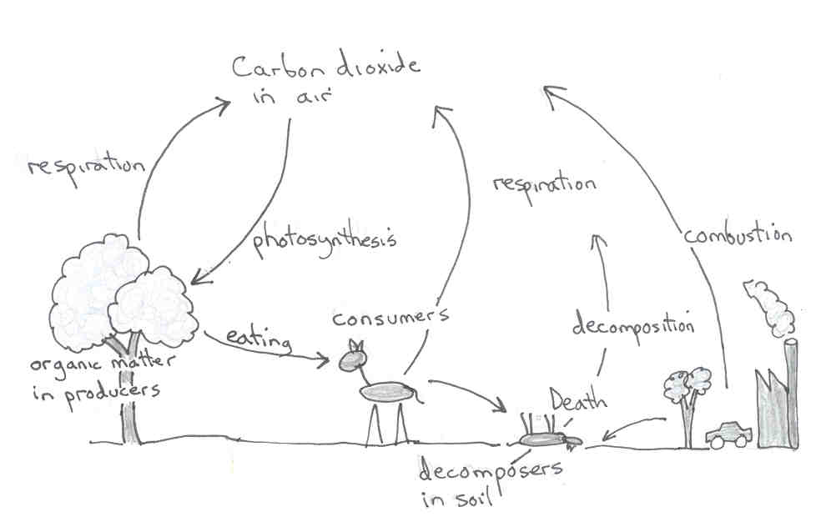

Description | Marks
Diagram clear and well labelled. | 1
Arrows indicating correct direction of carbon dioxide through cycle. | 1
Carbon dioxide enters green plant by diffusion via stomata when open. | 1
Used to produce sugar/carbohydrates during photosynthesis (equation not required). | 1
Energy stored in carbon-containing organic/carbohydrate molecules. | 1
Plants/carbohydrates consumed directly by herbivores/1º consumers to obtain energy. | 1
Plants/carbohydrates consumed indirectly by carnivores/2º consumers to obtain energy. | 1
CO₂ as waste product of cellular respiration, in both plants and animals, returns to air. | 1
Combustion: CO₂ also returns to air as product of pollution/burning of fossil fuel. | 1
Decomposers return carbon from the remains of dead plants and animals. | 1
(b) Adaptations for survival can be considered as structural, physiological or behavioural. Clearly distinguish the difference between the three types of adaptation and describe, using named examples, how each type of adaptation might help an organism survive in a terrestrial habitat.

Differences
Description | Marks
Structural: physical features, or altered (adapted) parts of the body, that aid survival. | 1
Physiological: a (internal) function of the organism’s body that is adapted to aid survival. | 1
Behavioural: actions performed by an organism that aid survival. | 1

Examples for survival in a terrestrial environment
Structural
 |  | Marks
Any suitable named example | Any related structural adaptation | 2
e.g. Penquins | Blubber/double layer feathers for warmth
e.g. Numbat | Tongue designed to collect termites
e.g. Mulga tree | Shaped to catch rain/extensive shallow root system

Physiological

 |  | Marks
Any suitable named example | Any related structural adaptation | 2
e.g. Penquins | Countercurrent heat exchange of blood to warm feet.
e.g. Quokkas | Survive long periods without water to drink.
e.g. Creosote bush | Roots produce toxins to prevent other plants growing.

Behavioural

 |  | Marks
Any suitable named example | Any related structural adaptation | 2
e.g. Desert hopping mouse | Burrowing/nocturnal to avoid heat/predators
e.g. Penquins | Huddle in groups for warmth
e.g. Mulga tree | Reduced number of stomata to preserve water.

Question 8

(a) Transpiration can be considered as a necessary evil for plants.

Using clearly labelled diagram(s) to support your answer summarise the process of transpiration and discuss why transpiration can be seen as an advantage and a disadvantage for plants.
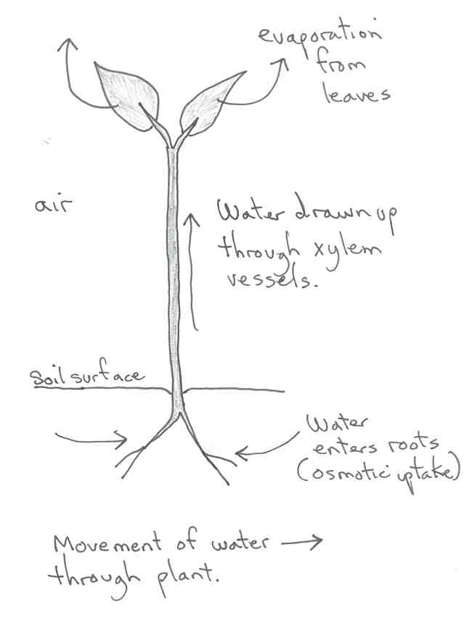
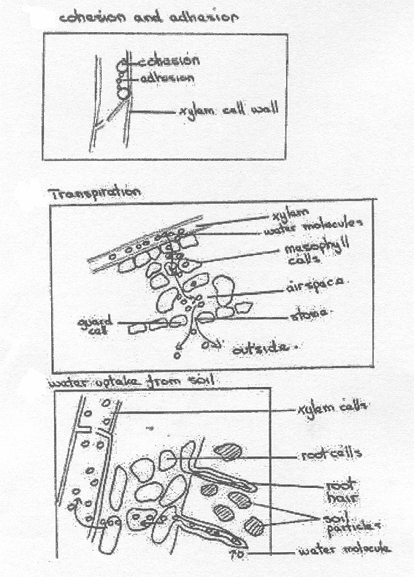

Description | Marks
Labelled diagram(s) similar to above that support summary points below. | 2
Transpiration: loss of water from the leaves causing movement of water from the roots. | 1
Process begins with evaporation mainly through stomata in leaves (due to a water potential difference between the atmosphere and the soil). | 1
Water drawn up xylem vessels: continuous/unbroken column of water (due to cohesion between water molecules and adhesion between water and xylem vessel walls). | 1
Water uptake: from soil into root hair cells by osmosis. | 1
Advantages: water supply for photosynthesis.  transport minerals to leaves.  no energy expended by plant (passive process). | 2
Disadvantages: water loss/wilting/dehydration.  restricts distribution of plants. | 2

(b) The cane toad (Bufo marinus) was introduced into Australia in 1935 to control the sugar cane beetle, but it proved to be ineffective. Since 1935, the cane toad population has been spreading and concern has increased about their effect on the environment. Studies into the feasibility of biological control have begun.
[From: Land Protection, 2006]

For copyright reasons this text cannot be reproduced in the online version of this document but may be viewed at http://www.nrw.qld.gov.au/factsheets/pdf/pest/pa21.pdf
(p.1, adaptation)

Suggest steps that should have been taken before the cane toad was first introduced to prevent it from becoming a pest and discuss the kinds of biological controls that might be used to control the cane toad population in the future.

Description | Marks
Research species in country of origin. | 1
Ensure specific to target organism (pest). | 1
Lengthy quarantine/isolation to study all aspects (complete life cycle, behaviour, etc.). | 1
Not poisonous/detrimental to native species (unlikely to introduce exotic disease). | 1
Not compete with native species for food/habitat/breeding grounds. | 1
Predator to kill and eat pest in preference to other prey. | 1
Parasite to weaken, kill or sterilise pest. | 1
Disease that targets pest. | 1
Competitor that reduces pest resources such as food, habitat and breeding grounds. | 1
Sterilize males (expense factor may be commented on). | 1

ACKNOWLEDGEMENTS

SECTION TWO

Question 6(b) Adapted from: Board of Studies New South Wales. (1998). 1998 Biology 2 Unit: Higher School Certificate Examination (pp. 22–23, q. 35(f)). Retrieved August, 2007, from http://www.boardofstudies.nsw.edu.au/hsc_exams/hsc2000exams/hsc00_biology/98BIOLGY.PDF.
© Board of Studies NSW for and on behalf of the Crown in right of the State of New South Wales

SECTION THREE

Question 8(b) Adapted from: Land Protection. (2006). Cane toad: Bufo marinus (p. 1). Retrieved August, 2007, from Department of Natural Resources and Water website: http://www.nrw.qld.gov.au/factsheets/pdf/pest/pa21.pdf.

Published by the Curriculum Council of Western Australia
27 Walters Drive
OSBORNE PARK WA 6017

Biology
Sample external written examination
Stage 2
Mapping questions to content

Course  content | Ecosystems: biodiversity and sustainability | Continuty of species | The functioning organism | Working as a Biologist

Section one-multiple choice
Question
1 | √
2 |  |  |  | √
3 |  |  |  | √
4 |  |  | √
5 |  |  | √
6 |  |  | √
7 |  | √
8 |  | √
9 |  | √
10 |  |  | √
11 | √
12 |  |  | √
13 | √
14 |  |  | √
15 |  |  | √
16 | √
17 | √
18 |  | √
19 |  |  |  | √
20 |  |  |  | √
Section two- short answers
21 |  |  |  | √
22 |  | √ | √
23 |  | √
24 | √
25 |  |  | √
26 | √
Section three-extended answers
27 | √ |  | √
28 | √ |  | √

